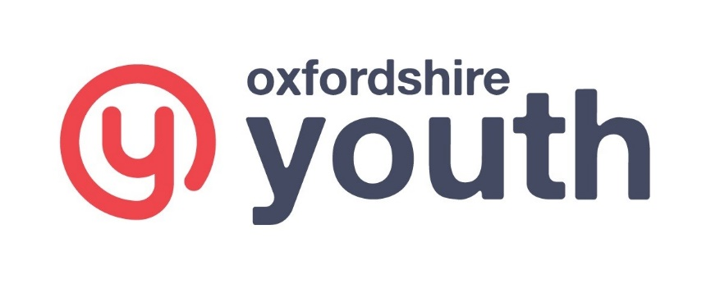

Oxfordshire Youth
DBS Privacy Policy for Standard and Enhanced Checks
Declaration of understanding

Privacy Policy- standard/enhanced checks (paper and e-Bulk applications) declaration

I have read the Standard/Enhanced Check Privacy Policy for applicants https://www.gov.uk/government/publications/dbs-privacy-policies and I understand how DBS will process my personal data and the options available to me for submitting an application.

Name……………………………………………………………………………………….

Signature………………………………………………………………………………….

Date…………………………………………..

