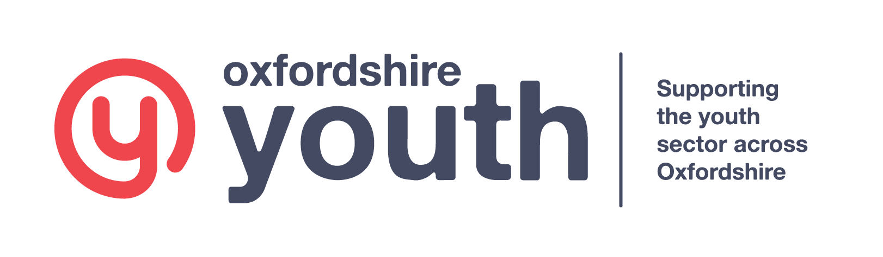

Consent/Membership Form
It is a requirement of ……………….. that all children/young people have a completed and signed consent/membership form. This form should be completed by the parent/guardian of any young person under the age of 16. Young people aged 16 and over can complete this form themselves. If any of these details change, it is the responsibility of the parent/guardian to inform ……………… so that we can amend our records accordingly. All information on this form will be kept according to our privacy policy and GDPR requirements.

Full name of young person
Gender

Date of birth

Address
(Including Postcode)

Young person email address
Full name of Parent/Carer
E-mail of Parent/Carer
Contact telephone number (s) for parent/ carer

Education and employment status | In School/college |  | Part time work |  |  | Other (please State)
Ethnicity of young person
Has the young person been diagnosed with any of the following: | Learning difficulty | Learning disability |  | Mental health issues | Physical disability |  | Behavioural disorder | Rather not say / None
Is the young person any of the following: | Young carer | In care |  | Homeless | Young offender |  | Young parent | Rather not say / None
Name of course

MEDICAL INFORMATION
Doctor’s Name:
Doctor’s Address:
Doctor’s Tel. No.:

Does this young person have any health problems, medical conditions or allergies etc. (e.g. asthma, diabetes, epilepsy)? If yes, please give details below:

Do any of these conditions require special medical treatment, including regular medication? If yes, please give details below:

Does this young person have any special dietary requirements? If yes, please give details below:
Swimming Ability (Please circle)

Non Swimmer Swims 10m Swims 25m Swims 50m Swims 50+
Has this young person received a tetanus injection in the last 5 years? YES / NO

Please give any other information you think may be useful:

We would appreciate alternative contact details (in case of emergency).
Name:
Relationship to
Young Person (e.g. aunt):
Address:
Telephone No.:

CONSENT FORM FOR USE OF PHOTOGRAPHS/VIDEOS
It is vital for us to gain your consent to take photos/videos of your child/young person and it is important that we are transparent in what we will do with these, how we will store these and how long we are going to keep these for. By ticking the box below, you are agreeing that you are happy with ……………………..[organisation name] to take photos/videos of your child/young person and that ……………………..[organisation name] to will maintain full rights to the use of these images and any reproductions or adaptations of the image for marketing and publicity purposes. This might include (but is not limited to) printed and online publications, press releases and funding applications. All this data will be stored in accordance with the General Data Protection Regulations and will be kept until the child/young person is 21 years old or for five years, dependant on which is later.
This consent form is valid until your child/young person reaches the age of 21 or for five years and ……………………..[organisation name] will not use photographs or videos after this time in new publications. However, those used in marketing materials that are already in the public domain may still remain in circulation after this time.
You can withdraw this consent at any time by emailing or writing to ……………………..[organisation name]. After consent is withdrawn, photographs and videos will no longer be used after a reasonable period. However, publicity that has already been published will remain in the public domain.
I give permission for photographs/videos of this young person to be used by ……………………..[organisation name] Tick

General Data Protection Regulations
Personal data collected in this form, will not be passed onto any third parties without your consent. Under the General Data Protection Regulations, you have a right to:
- Be informed about the use of your information
- Request a copy of the personal data we hold about you
- Correct any inaccuracies in relation to your information
- Withdraw your consent at any time so that no future contact is made or no future use of your images are made
- Obtain and use your own photographs or video images for your own purposes but not when this includes images of another individual

Parental Permission
To be signed only by a parent or other adult with parental responsibility or a young person over the age of 16
I give permission for this young person to take part in this organisation and I understand the nature of the activities that will be undertaken. I understand that the group leader and other workers, while taking all reasonable care in looking after this young person, cannot necessarily be held responsible for any loss, damage or injury suffered during, or as a result of, the group’s activities.

In an emergency, if I cannot be contacted despite all reasonable attempts to do so, I give permission for my son/daughter to undergo emergency medical/dental treatment including the use of anaesthetics as considered necessary and administered by suitably qualified medical practitioners.

Furthermore, I undertake to inform the group leader as soon as possible of any change in this young person’s medical condition where relevant.

Signature of parent/guardian: ______________________________ Date: _________________

PRIVACY NOTICE

Our aim is to become Oxfordshire’s leading provider of opportunities for young people and we are committed to providing the highest quality services. That is why we want to be completely transparent about why we need the personal details we request when you support us and how we will use them.

This Notice is designed to explain how and why information about you will be used by Oxfordshire Youth. The organisation may update this notice at any time and may also notify you in other ways from time to time about the way that we use your personal information.

How will we use information about you?

The organisation collects personal information in order to perform our key services. We are responsible by law for decisions relating to the security and use of your personal data. We will not use your information without your permission for purposes not directly related to the service we provide. It might be necessary to share your information for a purpose not related and without your permission if:
- Your health or safety, or that of others, is at risk
- We need to comply with a legal obligation.

How will your information be kept secure?
In order to ensure that your information is used appropriately and that your privacy is respected, your personal information will be held and used in compliance with the requirements of all applicable legislation. This means that:
- ……………..(organisation name) will take steps to ensure that your information is kept safe and that is it always accurate and up to date
- Only staff who need to do so will access your personal information
- Your personal details will be retained in accordance with our retention schedule (available upon request)

What are your rights?
Under the General Data Protection Regulations, you have a right to:
- Be informed about the use of your information
- Request a copy of the personal data we hold about you
- Correct any inaccuracies in relation to your information
- Withdraw your photo/video consent at any time so that no future contact is made or no future use of your images are made
- Obtain and use your own photographs or video images for your own purposes but not when this includes images of another individual

Changing your communication choices

If at any time you wish to change how we communicate with you, or update the information we hold, please do get in touch.
- Write to us: Oxfordshire Youth
Bury Knowle Coach House
North Place
Oxford
OX3 9HY
- Email us: https://www.oxfordshireyouth.org/contact-us/
- Call us (Mon-Fri 0900-1700): 01865 767899

